# VISVESVARAYA TECHNOLOGICAL UNIVERSITY

## BELAGAVI–590018, Karnataka

## INTERNSHIP REPORT

## ON

“WATSONISITE-INFORMATION ABOUT CRYPTO-SITE”

***Submitted in partial fulfilment for the award of degree(18ECI85)***

## BACHELOR OF ENGINEERING IN

## Electronics and Communication Engineering

***Submitted by:***

**AMAN KUMAR MANJHI**

#### 1MV19EC010



Conducted at

**Sain Informatix Pvt Ltd**



**SIR M. VISVESVARAYA INSTITUTE OF TECHNOLOGY**

# DEPARTMENT OF ELECTRONICS AND COMMUNICATION ENGINEERING

# Bengaluru -562157

**SIR M VISVESVARAYA INSTITUTE OF TECHNOLOGY**

**Accredited by NBA, New Delhi**

**ELECTRONICS AND COMMUNICATION ENGINEERING**

**BENGALURU- 562157**



**CERTIFICATE**

# 

This is to certify that the Internship titled **“WATSONISITE-INFORMATION ABOUT CRYPTO-SITE”** carried out by **AMAN KUMAR MANJHI (1MV19EC010)** bonafide student of **Sir M Visvesvaraya Institute of Technology**, in partial fulfilment for the award of **Bachelor of Engineering**, in **Electronics and communication** under **Visvesvaraya Technological University**, Belagavi, during the year 2022-2023. It is certified that all corrections/suggestions indicated have been incorporated in the report. The project report has been approved as it satisfies the academic requirements in respect of Internship prescribed for the course Internship / Professional Practice (18EC185).

#### Signature of Guide Signature of HOD Signature of Principal

**External Viva:**

Name of the Examiner Signature with Date

1)

2)

# D E C L A R A T I O N

I, **AMAN KUMAR MANJHI**, final year student of Electronics and Communication Engineering (ECE), **Sir M Visvesvaraya Institute of Technology-562157**, declare that the Internship has been successfully completed, in **SAIN INFORMATIX PVT LTD**. This report is submitted in partial fulfilment of the requirements for award of Bachelor Degree in Electronics and Communication Engineering, during the academic year 2022-2023.

.

Date: 23/09/2022 :

Place: BENGALURU

USN: 1MV19EC010

NAME: AMAN KUMAR MANJHI

**OFFER LETTER PROVIDED BY THE COMPANY**

# A C K N O W L E D G E M E N T

This Internship is a result of accumulated guidance, direction and support of several important persons. We take this opportunity to express our gratitude to all who have helped us to complete the Internship.

We express our sincere thanks to **Dr V. R. Manjunath**, Principal, SIR MVIT, for providing us adequate facilities to undertake this Internship.

We would like to thank **Dr. R Sundaraguru**, Professor & HOD, Dept. of ECE, for providing us an opportunity to carry out Internship and for his valuable guidance and support.

We would like to thank **Sain Informatix Pvt Ltd** for guiding us during the period of internship.

We would like to thank all the faculty members of our department for the support extended during the course of Internship. We would like to thank the non-teaching members of our dept, for helping us during the Internship.

Last but not the least, we would like to thank our parents and friends without whose constant help, the completion of Internship would have not been possible.

**AMAN KR. MANJHI**

**1MV19EC010**

# ABSTRACT

Website Design and learning Frontend and Backend designing were the main objectives of this internship. To develop a web-based application, there are several programming languages that can be used. Some of them are only used for the frontend and backend design of the software. For example, HTML3, HTML4, HTML5, CSS, Bootstrap, JavaScript etc. There are also some other programming languages that are used to develop the dynamic functions of the software or application. For example- PHP, Java etc. Nowadays there are also some frameworks that are used vastly. Frameworks are basically structured programming by using Model, View and Controller. It is also called as MVC. Solving real life problems was a key issue. This report takes us through all the details of Watsonisite. Watsonisite is a Crypto site, that includes information about crypto currencies, the trends, the price, and the performance of the particular crypto currency.

# Table of Contents

|  |  |  |
| --- | --- | --- |
| **Sl No.** | **Description** | **Page no.** |
| 1 | Company Profile | 9 |
| 2 | About the Company | 10-12 |
| [3](https://1.bp.blogspot.com/-dODuK8N5h1Q/Wlnyb3V9HFI/AAAAAAAACL4/WxQtCJ1pM5wccDABg4wIrTBUB0vlikXQQCLcBGAs/s1600/poly1.jpg) | Introduction | 13-15 |
| [4](https://1.bp.blogspot.com/-dODuK8N5h1Q/Wlnyb3V9HFI/AAAAAAAACL4/WxQtCJ1pM5wccDABg4wIrTBUB0vlikXQQCLcBGAs/s1600/poly1.jpg) | System Analysis | 16-17 |
| [5](https://1.bp.blogspot.com/-dODuK8N5h1Q/Wlnyb3V9HFI/AAAAAAAACL4/WxQtCJ1pM5wccDABg4wIrTBUB0vlikXQQCLcBGAs/s1600/poly1.jpg) | Requirement Analysis | 18-21 |
| 6 | Design [Analysis](https://4.bp.blogspot.com/-IOOxgPaXMVc/Wlj3LWvcnjI/AAAAAAAACKE/UeTFYvAxDmUDel5UBjdifeWaApB3-dXVgCLcBGAs/s1600/img1.jpg) | 22 |
| 7 | [Implementation](https://4.bp.blogspot.com/-IOOxgPaXMVc/Wlj3LWvcnjI/AAAAAAAACKE/UeTFYvAxDmUDel5UBjdifeWaApB3-dXVgCLcBGAs/s1600/img1.jpg) | 23 |
| 8 | Snapshots | 24-26 |
| 9 | Conclusion | 27 |
| 10 | References | 28 |

[CHAPTER](https://1.bp.blogspot.com/-dODuK8N5h1Q/Wlnyb3V9HFI/AAAAAAAACL4/WxQtCJ1pM5wccDABg4wIrTBUB0vlikXQQCLcBGAs/s1600/poly1.jpg)1

**COMPANY PROFILE**

## A Brief History of Sain Informatix

Sain Informatix, was incorporated with a goal “To provide high quality and optimal Technological Solutions to business requirements of our clients”. Every business is a different and has a unique business model and so are the technological requirements. They understand this and hence the solutions provided to these requirements are different as well. They focus on clients’ requirements and provide them with tailor made technological solutions. They also understand that Reach of their Product to its targeted market or the automation of the existing process into e-client and simple process are the key features that our clients desire from Technological Solution they are looking for and these are the features that we focus on while designing the solutions for their clients.

Sarvamoola Software Services. is a Technology Organization providing solutions for all web design and development, MYSQL, PYTHON Programming, HTML, CSS, ASP.NET and LINQ. Meeting the ever-increasing automation requirements, Sarvamoola Software Services. specialize in ERP, Connectivity, SEO Services, Conference Management, effective web promotion and tailor-made software products, designing solutions best suiting clients requirements.

Sain Informatix, strive to be the front runner in creativity and innovation in software development through their well-researched expertise and establish it as an out of the box software development company in Bangalore, India. As a software development company, they translate this software development expertise into value for their customers through their professional solutions.

They understand that the best desired output can be achieved only by understanding the clients demand better. Sain Informatix work with their clients and help them to defiine their exact solution requirement. Sometimes even they wonder that they have completely redefined their solution or new application requirement during the brainstorming session, and here they position themselves as an IT solutions consulting group comprising of high caliber consultants.

They believe that Technology when used properly can help any business to scale and achieve new heights of success. It helps Improve its efficiency, profitability, reliability; to put it in one sentence ” Technology helps you to Delight your Customers” and that is what we want to achieve.

[CHAPTER](https://1.bp.blogspot.com/-dODuK8N5h1Q/Wlnyb3V9HFI/AAAAAAAACL4/WxQtCJ1pM5wccDABg4wIrTBUB0vlikXQQCLcBGAs/s1600/poly1.jpg) 2

# ABOUT THE COMPANY

Sain Informatix is a Technology Organization providing solutions for all web design and development, MYSQL, PYTHON Programming, HTML, CSS, ASP.NET and LINQ. Meeting the ever-increasing automation requirements, Sain Informatix specialize in ERP, Connectivity, SEO Services, Conference Management, effective web promotion and tailor-made software products, designing solutions best suiting clients’ requirements. The organization where they have a right mix of professionals as a stakeholder to help us serve our clients with best of our capability and with at par industry standards. They have young, enthusiastic, passionate and creative Professionals to develop technological innovations in the field of Mobile technologies, Web applications as well as Business and Enterprise solution. Motto of our organization is to “Collaborate with our clients to provide them with best Technological solution hence creating Good Present and Better Future for our client which will bring a cascading a positive effect in their business shape as well”. Providing a Complete suite of technical solutions is not just our tag line, it is Our Vision for Our Clients and for Us, we strive hard to achieve it.

## Products of Sain Informatix.

**Android Apps**

It is the process by which new applications are created for devices running the Android operating system. Applications are usually developed in Java (and/or Kotlin; or other such option) programming language using the Android software development kit (SDK), but other development environments are also available, some such as Kotlin support the exact same Android APIs (and bytecode), while others such as Go have restricted API access.

The Android software development kit includes a comprehensive set of development tools. These include a debugger, libraries, a handset emulator based on QEMU, documentation, sample code, and tutorials. Currently supported development platforms include computers running Linux (any modern desktop Linux distribution), Mac OS X 10.5.8 or later, and Windows 7 or later. As of March 2015, the SDK is not available on Android itself, but software development is possible by using specialized Android applications.

**Web Application**

It is a client–server computer program in which the client (including the user interface and client- side logic) runs in a web browser. Common web applications include web mail, online

retail sales, online auctions, wikis, instant messaging services and many other functions. web applications use web documents written in a standard format such as HTML and JavaScript, which are supported by a variety of web browsers. Web applications can be considered as a specific variant of client–server software where the client software is downloaded to the client machine when visiting the relevant web page, using standard procedures such as HTTP. The Client web software updates may happen each time the web page is visited. During the session, the web browser interprets and displays the pages, and acts as the universal client for any web application. The use of web application frameworks can often reduce the number of errors in a program, both by making the code simpler, and by allowing one team to concentrate on the framework while another focuses on a specified use case. In applications which are exposed to constant hacking attempts on the Internet, security- related problems can be caused by errors in the program.

Frameworks can also promote the use of best practices such as GET after POST. There are some who view a web application as a two-tier architecture. This can be a “smart” client that performs all the work and queries a “dumb” server, or a “dumb” client that relies on a “smart” server. The client would handle the presentation tier, the server would have the database (storage tier), and the business logic (application tier) would be on one of them or on both. While this increases the scalability of the applications and separates the display and the database, it still doesn’t allow for true specialization of layers, so most applications will outgrow this model. An emerging strategy for application software companies is to provide web access to software previously distributed as local applications. Depending on the type of application, it may require the development of an entirely different browser-based interface, or merely adapting an existing application to use different presentation technology. These programs allow the user to pay a monthly or yearly fee for use of a software application without having to install it on a local hard drive. A company which follows this strategy is known as an application service provider (ASP), and ASPs are currently receiving much attention in the software industry.

Security breaches on these kinds of applications are a major concern because it can involve both enterprise information and private customer data. Protecting these assets is an important part of any web application and there are some key operational areas that must be included in the development process. This includes processes for authentication, authorization, asset handling, input, and logging and auditing. Building security into the applications from the beginning can be more effective and less disruptive in the long run.

**Web design**

It is encompassing many different skills and disciplines in the production and maintenance of websites. The different areas of web design include web graphic design; interface design; authoring, including standardized code and proprietary software; user experience design; and

search engine optimization. The term web design is normally used to describe the design process relating to the front-end (client side) design of a website including writing mark up. Web design partially overlaps web engineering in the broader scope of web development. Web designers are expected to have an awareness of usability and if their role involves creating markup then they are also expected to be up to date with web accessibility guidelines. Web design partially overlaps web engineering in the broader scope of web development.

## Departments and services offered

Sain Informatix plays an essential role as an institute, the level of education, development of student’s skills are based on their trainers. If you do not have a good mentor then you may lag in many things from others and that is why we at Sain Informatix gives you the facility of skilled employees so that you do not feel unsecured about the academics. Personality development and academic status are some of those things which lie on mentor’s hands. If you are trained well then you can do well in your future and knowing its importance of Sain Informatix always tries to give you the best.

They have a great team of skilled mentors who are always ready to direct their trainees in the best possible way they can and to ensure the skills of mentors we held many skills development programs as well so that each and every mentor can develop their own skills with the demands of the companies so that they can prepare a complete packaged trainee.

## Services provided by Sain Informatix.

* Core Java and Advanced Java
* Web services and development
* Dot Net Framework
* Python
* Selenium Testing
* Conference / Event Management Service
* Academic Project Guidance
* On The Job Training
* Software Training

[CHAPTER](https://1.bp.blogspot.com/-dODuK8N5h1Q/Wlnyb3V9HFI/AAAAAAAACL4/WxQtCJ1pM5wccDABg4wIrTBUB0vlikXQQCLcBGAs/s1600/poly1.jpg) 3

**INTRODUCTION**

Introduction to Web Apps

Web applications are similar to the traditional applications you’d install on your Information, such as Microsoft Office. They are able to perform the same kinds of tasks, they look the same and they feel the same but there is one key difference - the application itself is not installed on your phone or Information, but lives in the cloud. Web apps are not new, but it used to be that they were often unable to compete with more traditional applications for business-critical functions or where rich user interaction was required. This is no longer the case. With the power of modern web technologies, we are able to design and build performing, secure, and feature rich applications that live in the cloud and bring with them a huge number of benefits.

#### They can be accessed from anywhere.

* Because web applications are built with web technologies and they run in a web browser Internet Explorer, Google Chrome, Mozilla Firefox – this allows them to be accessed from every web enabled tool. As long as you have an internet connection you can use them.
* It allows for remote working, it allows for rapid publishing of content, it allows for real time collaboration between teams. If you have web access, you have the ability to access your business tools.

#### They are cost effective.

* Web applications are cheaper to produce and maintain than traditional applications. No matter how many platforms your business uses (Mac, Linux, Windows) web application build can be used across them all.

#### They benefit from more rapid update cycles.

* A huge benefit of web applications is that when an update is released, all of your users are immediately using that version. This doesn’t happen with installed applications, especially in large organizations with IT policies that restrict administrator access.

#### They are secure.

* Web developers have had to become experts in security – the web is a platform designed to share everything with everyone! As such, the types and levels of security included in web applications are often far greater than those seen in traditional applications.
* They also benefit from the ability to launch updates in real-time – the application on the servers is the application people are using. The applications on people’s laptops however is the version last installed. And when those laptops get left on a train it’s not a concern, as nothing is stored locally.

#### They enable more computing with fewer Information.

* Web applications push all of the hard work to the servers, and act as intermediaries between the user interface and the calculations happening behind the scenes. This means you can accomplish terrifyingly complex work on a tablet, or your phone.
* We’ve built web applications that allow people to understand the complex relationships between 250,000 pieces of art on their phones, and applications that run the business systems of one of the largest solar energy providers in the world. Often these products are not financially viable to build using traditional application processes.

## Problem Statement

To develop a complete responsive Crypto site that includes information about different kinds of crypto currencies, the trends, the price, and the performance of the particular crypto currency. It also shows the ratings of each cryptocurrency and reviews from the users. It informs the user about the constant change in prices of different types of crypto. The usage of the concept of live value tracking of various crypto currencies means that the user can constantly stay up to date with the change in values by the minute and plan his investment accordingly. It provides an excellent means of connecting a new user to crypto and the trend with which its value goes up or down, giving him an idea about the crypto industry.

## Introduction to Watsonisite Information about crypto-site

Watsonisite is a Crypto site that includes information about cryptocurrencies, the trends, the price, and the performance of those particular cryptocurrencies. This is an informative site and no connection has been made to any other website or a web service where the user has the option to invest any money on crypto. Essentially, this website acts as a guide to the user showing him or her, trends of the growth or fall of the crypto currency in concern.

The website also presents the user with a login page where he or she can actually create an account using which the person can track the status and access the various features of the website.

As an additional feature, the website also offers a sliding row where prices of different crypto currencies are shown and updated in real time. This gives the user the look and feel of a professional website that reports news and other important details that he or she might need to know and provides a feeling of professionalism.

# [CHAPTER](https://1.bp.blogspot.com/-dODuK8N5h1Q/Wlnyb3V9HFI/AAAAAAAACL4/WxQtCJ1pM5wccDABg4wIrTBUB0vlikXQQCLcBGAs/s1600/poly1.jpg) 4 SYSTEM ANALYSIS

## Existing System:

## The last 5 years has seen a massive growth of crypto currencies in terms of the volume generated and the popularity of these currencies.

## Due to the recent massive growth of crypto, the industry still hasn’t completely caught up with the demand of the market in terms of making a user friendly, and a fully functional informative website.

## In terms of user retention on the website, an attractive graphical interface with pictures and information presented in a good, neat, readable format is essential in order to make the users feel content with the information given to them.

## There is also a lack of consistently updating real time prices on each of the crypto, making most of the websites available today for crypto highly unreliable.

## Proposed System:

## The utilization of a concept such as dynamically updating the crypto values of each kind of currency at regular intervals helps the user track the market values for each kind of currency.

## Even though the website is not designed to assist the user with his investment directly, it indirectly helps him or her with their investments by providing other useful services.

## There is a feature implemented in the website consisting of a login page with an ability to

## login with either your Google or Facebook account, or any other email address in case the user does not have either of the two.

## This provides a sense of privacy to the user and the ability to login from anywhere and check the status of crypto at any point of time

## The website also provides assistance and helps the users with a Cryptocurrency mining server, Crypto currency trading bot, tracking cryptocurrency stats over time, etc.

## Objective of the System

## The website that was designed aimed to overcome the shortcomings that the existing system possessed.

## One of the major objectives of this designed system was to have a good looking, properly functional, neatly organized and a descriptive website that aimed at providing the best informative service to its users.

## We were able to achieve this by using simple, open-source software tools and utilizing them to the best of our abilities in order to design a product that would excite people to come back and visit, either for getting an idea about their next investment or for someone to get some basic knowledge about crypto and slowly getting their feet into the deep waters of crypto.

# [CHAPTER](https://1.bp.blogspot.com/-dODuK8N5h1Q/Wlnyb3V9HFI/AAAAAAAACL4/WxQtCJ1pM5wccDABg4wIrTBUB0vlikXQQCLcBGAs/s1600/poly1.jpg) 5 REQUIREMENT ANALYSIS

## Hardware Requirement Specification

* + MySQL
  + NODE JS
  + Notepad++ Editor
  + Processor: Intel core i5 processer
  + Memory: 15.6 GB
  + Hard Disk: 40 GB

## Software Requirement Specification

### Functional Requirements

### HTML5:

### HTML stands for Hyper Text Mark-up Language. It is used to design web pages using mark-up language. HTML is the combination of Hypertext and Mark-up language. Hypertext defines the link between the web pages. Mark-up language is used to define the text document within tag which defines the structure of web pages. HTML5 is the fifth and current version of HTML. It has improved the mark-up available for documents and has introduced application programming interfaces (API) and Document Object Model (DOM).

### CSS:

### Cascading Style Sheets, fondly referred to as CSS, is a simply designed language intended to simplify the process of making web pages presentable. CSS allows you to apply styles to web pages. More importantly, CSS enables you to do this independent of the HTML that makes up each web page. There are three types of CSS which are: Inline CSS, Internal or Embedded CSS, External CSS.

### JavaScript:

### JavaScript is a lightweight, cross-platform and interpreted scripting language. It is well-known for the development of web pages; many non-browser environments also use it. JavaScript can be used for Client-side developments as well as Server-side developments.

### Features of JavaScript:

### * According to a recent survey conducted by Stack Overflow, JavaScript is the most popular language on earth. With advances in browser technology and JavaScript having moved into the server with Node.js and other frameworks, JavaScript is capable of so much more.

### * Functions in JS are objects. They may have properties and methods just like another object. They can be passed as arguments in other functions.

### * Can handle date and time.

### * Performs Form Validation although the forms are created using HTML.

### * No compiler needed.

### Python Django library:

### Python Django is a web framework that allows to quickly create efficient web pages. Django is also called batteries included framework because it provides built-in features such as Django Admin Interface, default database – SQLite3, etc.

### Django Architecture: Django is based on MVT (Model-View-Template) architecture which has the following three parts –

### Model: The model is going to act as the interface of your data. It is responsible for maintaining data. It is the logical data structure behind the entire application and is represented by a database (generally relational databases such as MySQL, Postgres).

### View: The View is the user interface that you see in your browser when you render a website. It is represented by HTML/CSS/JavaScript and Jinja files.

### Template: A template consists of static parts of the desired HTML output as well as some special syntax describing how dynamic content will be inserted.

### Visual code studio (Text editor):

### Visual Studio is an Integrated Development Environment (IDE) developed by Microsoft to develop GUI (Graphical User Interface), console, Web applications, web apps, mobile apps, cloud, and web services, etc. With the help of this IDE, you can create managed code as well as native code. It uses the various platforms of Microsoft software development software like Windows store, Microsoft Silverlight, and Windows API, etc. It is not a language-specific IDE as you can use this to write code in C#, C++, VB (Visual Basic), Python, JavaScript, and many more languages. It provides support for 36 different programming languages. It is available for Windows as well as for macOS.

### Components:

### 1. Code Editor: Where the user will write code.

### 2. Output Window: Here the Visual Studio shows the outputs, compiler warnings, error messages and debugging information.

### 3. Solution Explorer: It shows the files on which the user is currently working.

### 4. Properties: It will give additional information and context about the selected parts of the current project.

### B] Non-Functional Requirements

#### Availability:

The online registration system shall permit backing up of the registration database while other registration actives are going on.

#### Accessibility

The system shall be accessible by people with specific vision needs to the extent that a shall be able to display whole user interface in a larger font without truncating displayed text or other values.

#### Security

The access permissions for system data may only be change by the systems data administrator passwords shall never be viewable at the point of entry or any other time.

[CHAPTER](https://1.bp.blogspot.com/-dODuK8N5h1Q/Wlnyb3V9HFI/AAAAAAAACL4/WxQtCJ1pM5wccDABg4wIrTBUB0vlikXQQCLcBGAs/s1600/poly1.jpg) 6

**DESIGN ANALYSIS**

**USER RESEARCH**

It was a new learning experience for me as I chose this project because I wanted to know how crypto currency websites work and what problems users were facing. So, I conducted user research to understand what pain points they had and empathize with them to understand exactly how they feel.

**DESIGN PROCESS**

**Once we performed a market analysis on the problems that the various users of crypto websites were facing, the next step in order to design a crypto website was to understand the outline and visualizing what the final website would look like.**

**This helped as we could get an idea as to what tools had to be used with the web design and we could update ourselves with those tools if and when necessary, in order to make the website as user friendly and informative as possible.**

We then had to make sure that the website that was made was compatible on both phones and laptops because the user who has no access to a laptop at the moment should also be able to access it conveniently.

# [CHAPTE](https://1.bp.blogspot.com/-dODuK8N5h1Q/Wlnyb3V9HFI/AAAAAAAACL4/WxQtCJ1pM5wccDABg4wIrTBUB0vlikXQQCLcBGAs/s1600/poly1.jpg)R 7

# IMPLEMENTATION

Implementation is the stage where the theoretical design is turned into a working system. The most crucial stage in achieving a new successful system and in giving confidence on the new system for the users that it will work efficiently and effectively.

The system can be implemented only after thorough testing is done and if it is found to work according to the specification. It involves careful planning, investigation of the current system and it constraints on implementation, design of methods to achieve the changeover and an evaluation of change over methods a part from planning.

Two major tasks of preparing the implementation are education and training of the users and testing of the system. The more complex the system being implemented, the more involved will be the system analysis and design effort required just for implementation.

The implementation phase comprises of several activities. The required hardware and software acquisition is carried out. The system may require some software to be developed. For this, programs are written and tested. The user then changes over to his new fully tested system and the old system is discontinued.

## TESTING

The testing phase is an important part of software development. It is the Information zed system will help in automate process of finding errors and missing operations and also a complete verification to determine whether the objectives are met and the user requirements are satisfied. Software testing is carried out in three steps:

1. The first includes unit testing, where in each module is tested to provide its correctness, validity and also determine any missing operations and to verify whether the objectives have been met. Errors are noted down and corrected immediately.
2. Unit testing is the important and major part of the project. So, errors are rectified easily in particular module and program clarity is increased. In this project entire system is divided into several modules and is developed individually. So, unit testing is conducted to individual modules.
3. The second step includes Integration testing. It need not be the case, the software whose modules when run individually and showing perfect results, will also show perfect results when run as a whole.

# [CHAPTE](https://1.bp.blogspot.com/-dODuK8N5h1Q/Wlnyb3V9HFI/AAAAAAAACL4/WxQtCJ1pM5wccDABg4wIrTBUB0vlikXQQCLcBGAs/s1600/poly1.jpg)R 8

# SNAPSHOTS

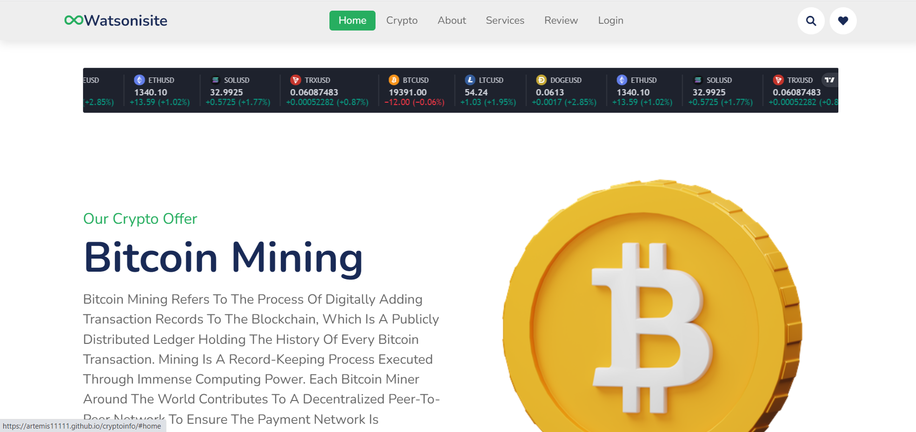

**PIC 1: “HOME PAGE” OF THE CRYPTOSITE SHOWING LIVE PRICES USING MOTION SLIDER**

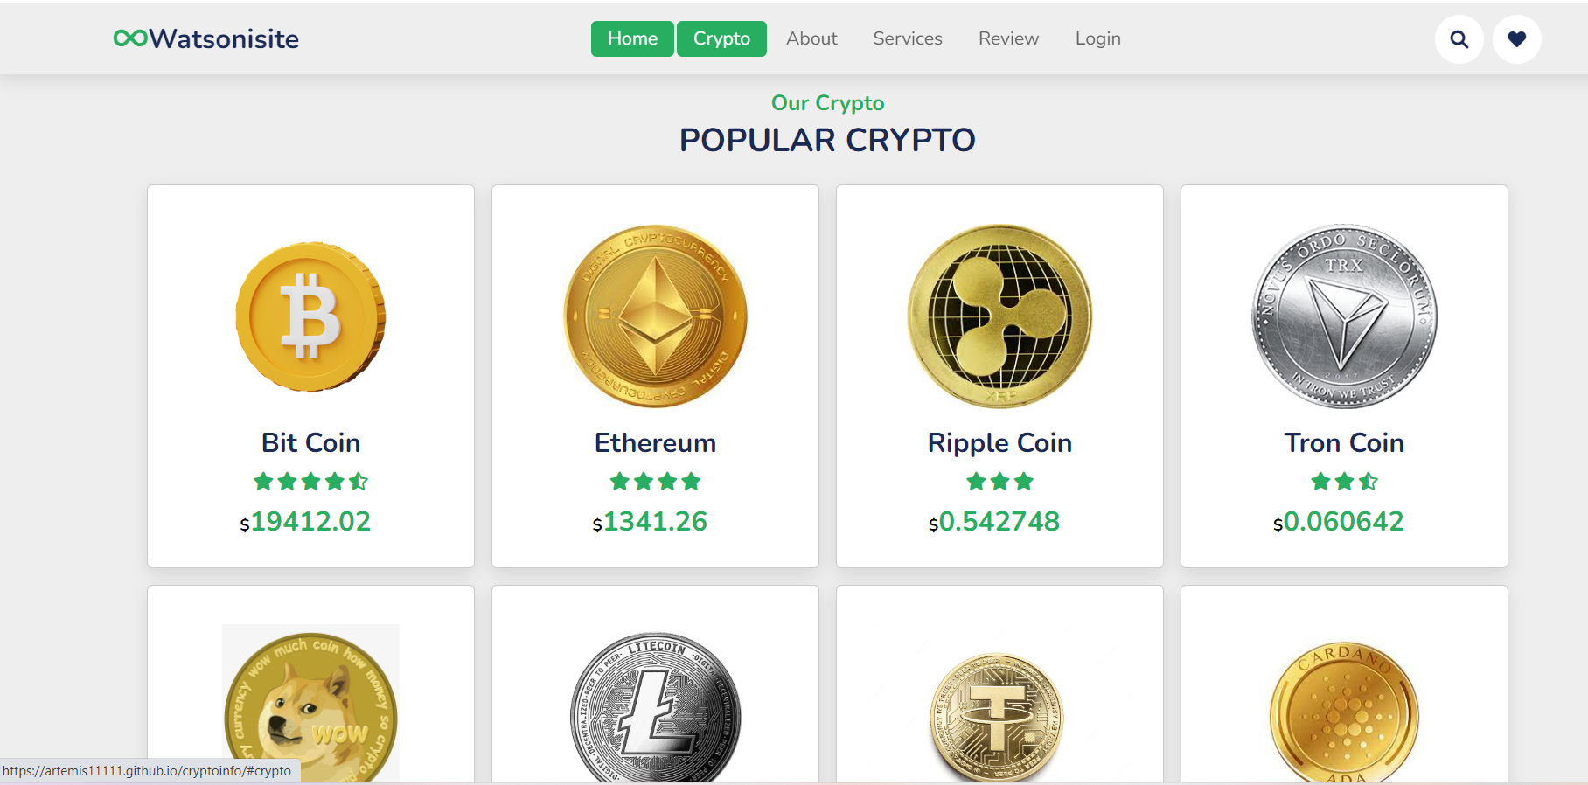

**PIC 2: DIFFERENT CRYPTO COINS SHOWING LIVE PRICES**



**PIC 3: “ABOUT US” SECTION DESCRIBING THE REASON TO CHOOSE US FOR INFORMATION**

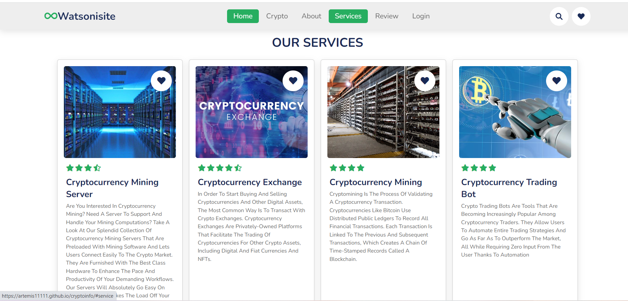

**PIC 4: “SERVICES” SECTION SHOWING OTHER FEATURES CAN BE USED FROM OUR WEBSITE**

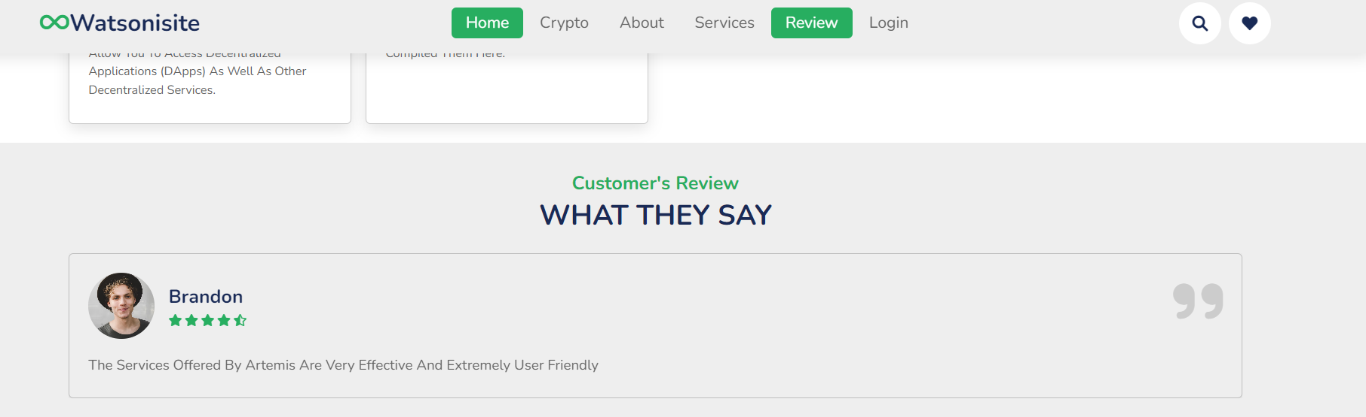

**PIC 5: “REVIEW” SECTION SHOWING WHAT USERS SAY ABOUT OUR INFORMATION**

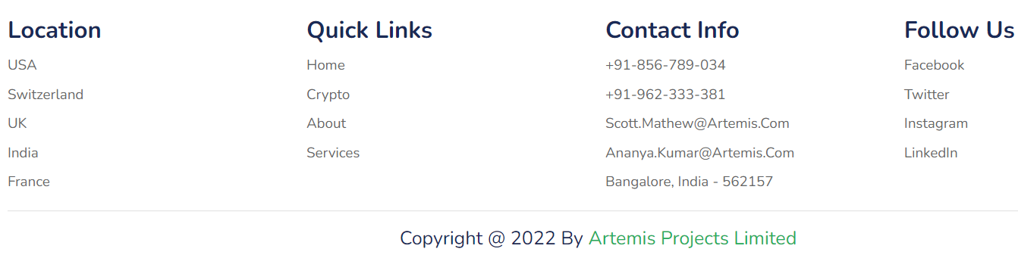

**PIC 6: DIRECT CONNECTION TO SOCIAL NETWORKING SITES AND CONTACT INFORMATION**

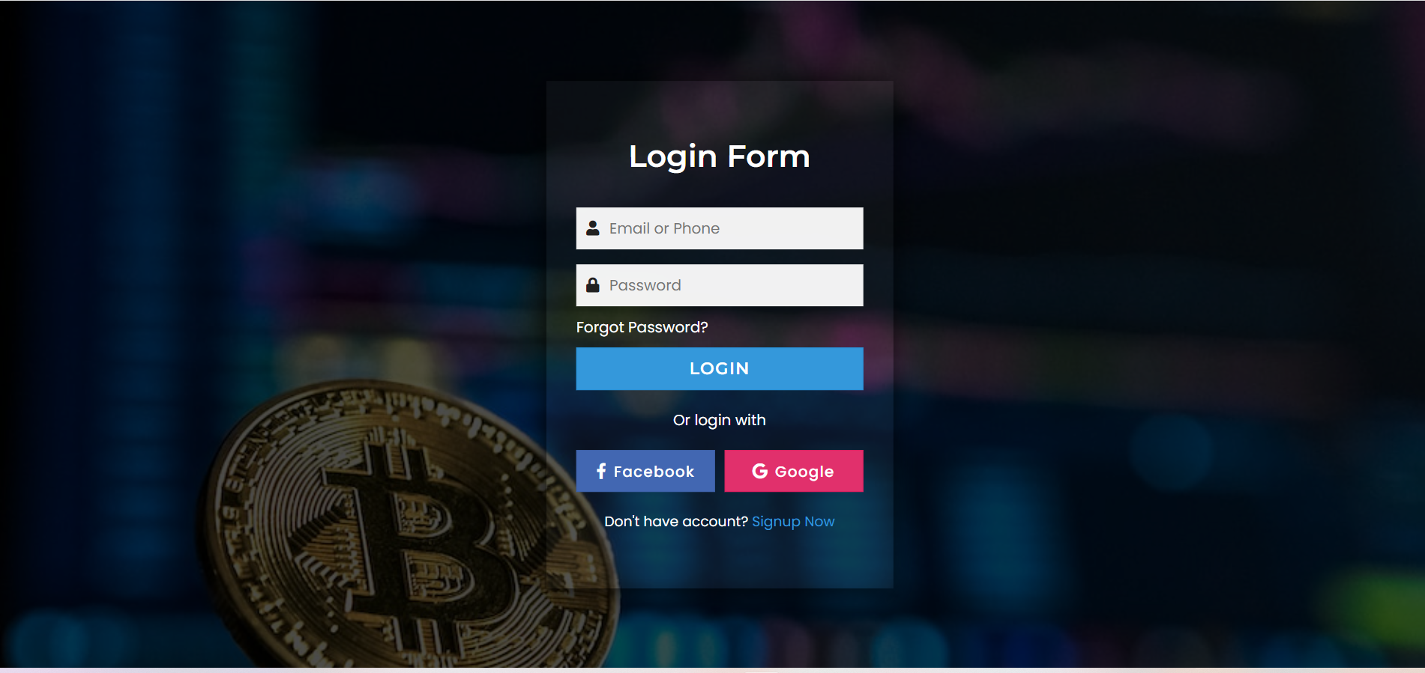

**PIC 7: LOGIN PAGE FOR USERS**

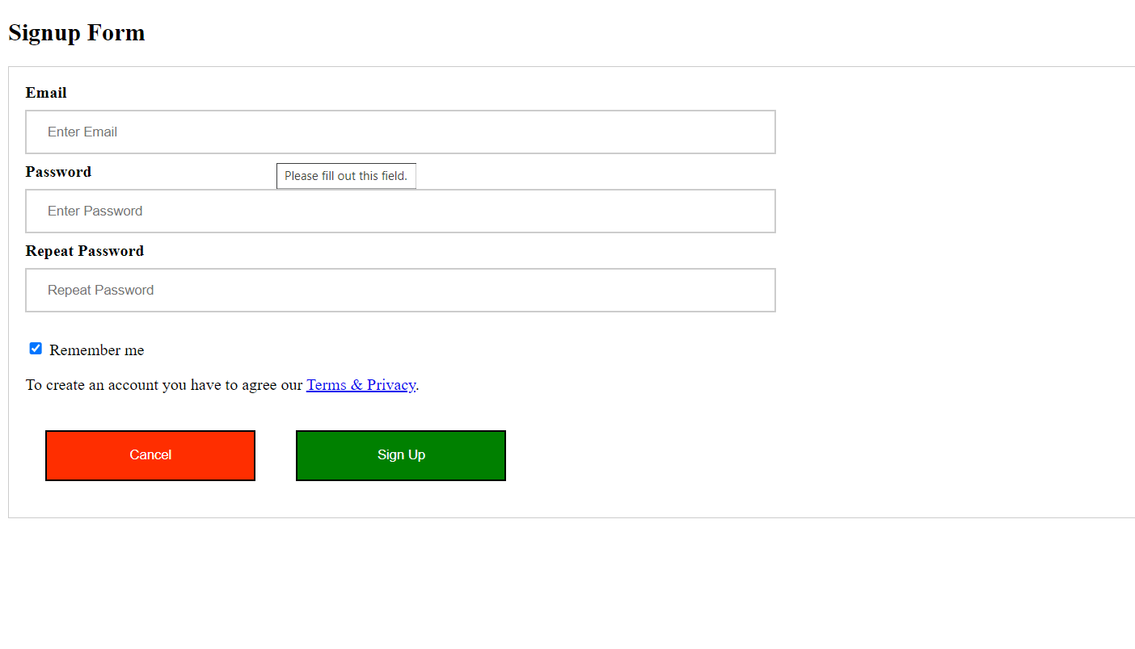

**PIC 8: SIGNUP PAGE FOR NEW USERS**

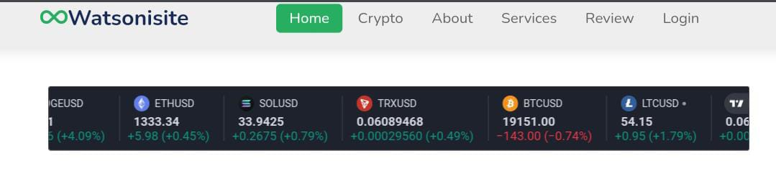 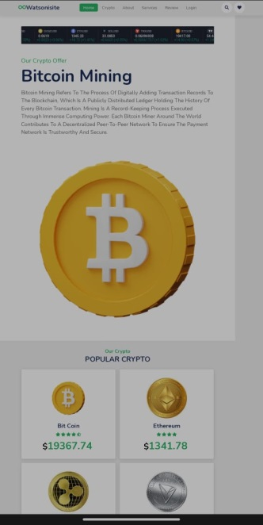 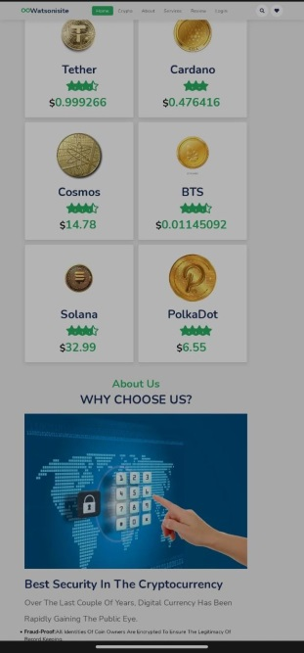

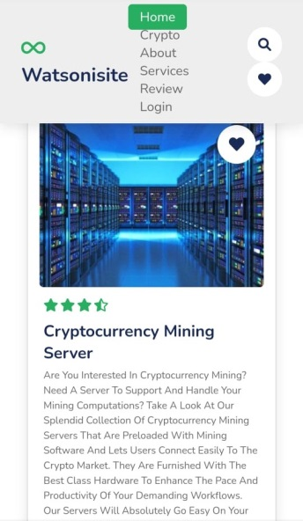 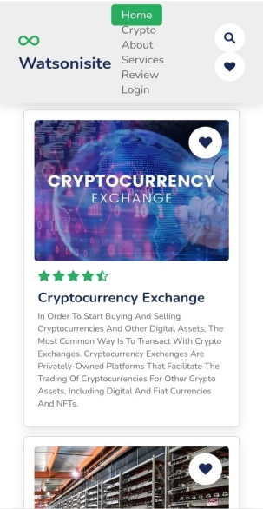 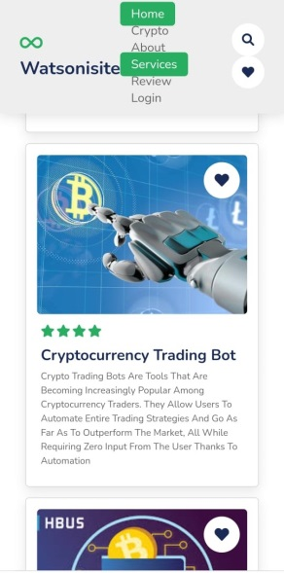

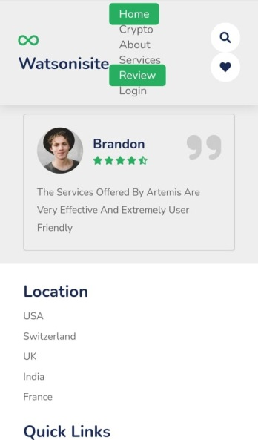 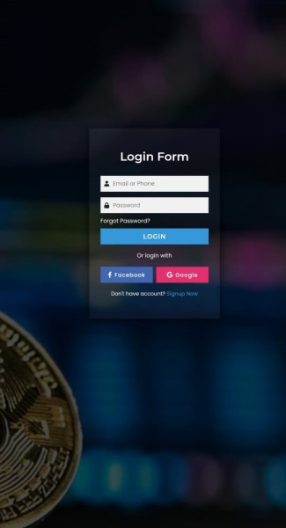 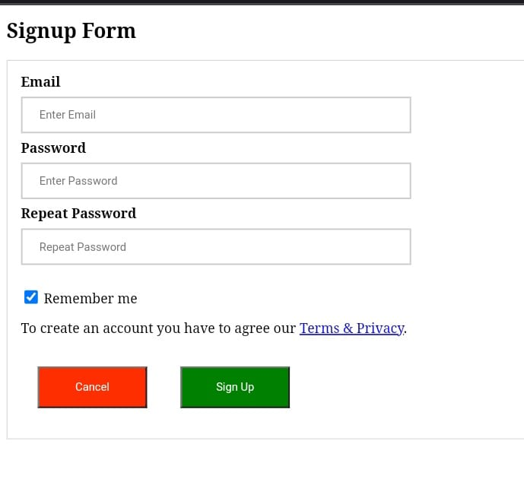

**PIC 9: OPENING THE WEBSITE IN MOBILE PHONE**

# [CHAPTE](https://1.bp.blogspot.com/-dODuK8N5h1Q/Wlnyb3V9HFI/AAAAAAAACL4/WxQtCJ1pM5wccDABg4wIrTBUB0vlikXQQCLcBGAs/s1600/poly1.jpg)R 9 CONCLUSION

The package was designed in such a way that future modifications can be done easily. The following conclusions can be deduced from the development of the project:

* Automation of the entire system improves the efficiency
* It provides a friendly graphical user interface which proves to be better when compared to the existing system.
* It gives appropriate access to the authorized users depending on their permissions.
* It effectively overcomes the delay in communications.
* Updating of information becomes so easier
* System security, data security and reliability are the striking features.
* The System has adequate scope for modification in future if it is necessary.

# 

# [CHAPTE](https://1.bp.blogspot.com/-dODuK8N5h1Q/Wlnyb3V9HFI/AAAAAAAACL4/WxQtCJ1pM5wccDABg4wIrTBUB0vlikXQQCLcBGAs/s1600/poly1.jpg)R 10

# REFERENCES

1. <https://www.educba.com/design-web-page-in-html/>
2. <https://www.geeksforgeeks.org/design-a-web-page-using-html-and-css/>
3. https://www.youtube.com/watch?v=qz0aGYrrlhU